Образец письменной части экзамена по английскому языку 1 курс 4 модуль1
№ | Раздел работы | Возможные задания | Удельный вес
1 | Аудирование | - Прослушайте текст и определите, какие из утверждений, высказываютсякаждым изговорящих.  - Прослушайте текст повторно изаполните таблицу. | 20 баллов
2 | Чтение | - Прочитайте текст и определите, какие из утверждений, предложенных в тексте, верны (Верно), какие нет (Неверно) и о чем в тексте не сказано, то есть на основании текста нельзя дать ни положительного, ни отрицательного ответа (В тексте не сказано)  - Заполните предложенные ниже утверждения, использую не более 3х слов из текста. | 20 баллов
3 | Письмо | - Написание определенного типа абзаца  - Описание графика  (выполняется одно задание из двух на выбор) | 20 баллов
4 | Говорение | - Монолог на заданную тему (с предварительной подготовкой в течение 1 минуты)  - Ответы на вопросы по трем пройденным темам (без подготовки) | 20 баллов

1 Задания, представленные в данном документе, иллюстрируют тип предложенного
задания. Количество вопросов и уровень языка может отличаться от количества вопросов и уровня языка в реальных вариантах

Раздел 1

АУДИРОВАНИЕ
Listen to the dialogue between two students. Match each opinion (1-5) with the person who shares it (A-C) NB: You may use any letter more than once.

Write A for Adam
B for Emma
or C for Both

- The Sports Centre should have social areas for people to have a coffee and chat.
- Sauna is considered to be dangerous if people don’t use it wisely.
- If there is a hospital or a medical center nearby minor injuries could be treated off- site.
- Sports science lectures should have an opportunity to give lectures inside the Sports Centre.
- A state-of-the-art sport center should have a couple of jacuzzis on-site.

Listen to the recording again. Decide where the sports mentioned below can be played. Complete the chart with the appropriate name of the sport (6-10).

Basketball
Football
Rugby
Squash
Swimming
Table tennis
Volleyball

In the Sports Centre | Elsewhere in the University | In the city
6. | 7. | 10.
 | 8.
 | 9.

Script
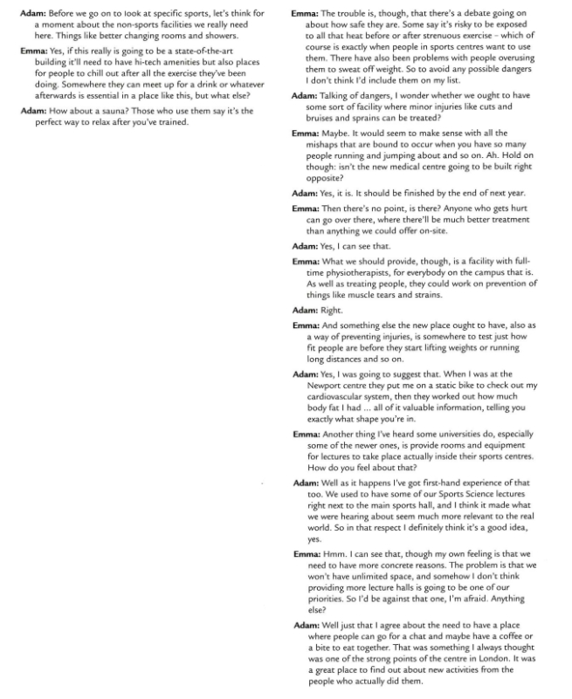

Раздел 2

ЧТЕНИЕ

TASK 1.
Read the text and decide whether the following statements (11-15) agree with the information given in the text. Mark them:
T (True) if the statement agrees with the text
F (False) if the statement does not agree with the text
NG (Not Given) if there is no information about this in the text

- Women love shopping, while men hateit.
- Addiction to shopping can have negative impact on one’slife.
- People tend to buy more when they are not content with theirlives.
- A lot of people use credit cards as this simplifies budgetmanagement.
- Shopaholics are more difficult to cure than people with alcohol or drugaddiction.

WHEN SHOPPING IS A PROBLEM
For a lot of people, shopping is a chore, something tedious, yet necessary – like housework. For others, shopping is fun, a release from the world of work. For a minority, however, shopping can be as dangerous as consuming too much alcohol or abusing drugs. For these “shopaholics”, a trip to a department store can become a way of fueling an addiction.
How does this happen and why? Psychologists believe that the “shopaholic” views spending money as a form of escapism and a means of achieving happiness. The real problem starts, however, when the constant need to buy new things starts interfering with a person’s life. People who become addicted to the excitement of shopping believe that buying something new will make their lives happier and more fulfilling.
People frequently become shopaholics because their lives are emotionally empty. It is often a sign of chronic depression. People fill their lives with “things” because they can’t face their own unhappiness. Shopping then becomes a form of therapy. According to experts, women are particularly prone to this sort of behavior. This may be because so much advertising is targeted at women. Magazine and television advertising aimed at them as career women, wives and mothers, puts women under a lot of pressure to buy.
Buying your way out of an emotional crisis is not a healthy option, though. Spending can get out of control. People get caught in a situation in which the “high” of spending money is soon replaced by disappointment, and finally depression, as the debts pile up. New things quickly lose their attraction and then the desire to shop and spend starts all over again.
The widespread use of credit cards has led to a marked increase in the number of shopaholics. According to experts, the banks have made credit cards too easy to obtain,

with the result that more and more people are using them. Using a credit card gives one the illusion that no money is being spent. People can go on for years, spending vast sums on credit without realizing it. As a result, they end up either with huge overdrafts or in court, filing for bankruptcy.
Unlike a dependency on alcohol or drugs, an addiction to shopping and spending money is less easy to detect but, as with other forms of addiction, the “shopaholic” is also in need of professional help. It seems, then, that the solution to the problem lies with the therapists who specialize in this disorder, and with the patients themselves. Getting to the root of the shopaholic’s depression and helping the shopaholic to face up to and cope with the real problems that trigger their shopping mania is the only practical approach. Buying yet another dress is not theanswer.

TASK 2.
Read the text below and complete the sentences 6-10. Write no more than three words.

- Scientists believe that there is a number of ways to think about time, which are distributed equally among the past, the present and the future: …………….. time zones each.
- People who keep family records and remember good times are called .……………
- Present hedonists live for …………….. , trying to seek sensation andavoid pain.
- People who prefer work to play and don’t give in to temptation make decisions onthe ground of ………………
- Future fatalists have a strong belief in life after death and importanceof
…………….. in life.

According to social psychologists, there are six ways of thinking about time, which are called personal time zones. The first two are based in the past. Past positive thinkers spend most of their time in the state of nostalgia, finely remembering moments such as birthdays, marriages and important achievements in their life. These are the kind of people who keep family records, books and photo albums. People living in the past negative time zone are also absorbed by earlier times, but they focus on all the bad things: regrets, failures, poor decisions. They spend a lot of time thinking about how life could havebeen.

Then we have people who live in the present. Present hedonists are driven by pleasure and immediate sensation. Their life model is to have a good time and avoid pain. Present fatalists live in the moment too, but they think this moment is a product of circumstances entirely beyond their control. It’s their fate; whether it’s poverty, religion or society itself. Something stops these people from thinking they can play a role and changing their outcome in life. Life simply is and that’sthat.

Looking at the future time zone we can see that people who classify this future active are the planners and go-getters. They work rather than play and resist temptation. Decisions are made based on potential consequences, not on the experience itself. A second future- orientated perspective, future fatalistic, is driven by the certainty of life after death and some kind of a judgment day when they’ll be assessed on how virtuously they’ve lived and what success they’ve had in their lives.

Раздел 3

ПИСЬМО2

Task 1
- Write a paragraph comparing/contrasting life in a large city and inthe countryside. Write 120-150 words.
- Write a paragraph to describe your favoritepastime. Write 120-150 words.
- Write a paragraph to explain the reasons why social networking is so popularwith young peoplenowadays. Write 120-150 words.
Task 2

Write the description of the pie chart/table/diagram/line graph/bar chart below. Report the key features in 120-150 words.

2 120-150 слов

Раздел 4

ГОВОРЕНИЕ3

TASK 1. In 1 minute be ready to describe someone you know who is popular in your neighborhood.

You should say:
- who this personis
- when you first met thisperson
- what sort of person he/sheis

and explain why you think the person is popular.

TASK 2. Answer the following questions. Express and justify your opinion.

  - Do you think it’s important to have good communication skills to do a job well? (Why? / Whynot?)

  - Some people think it is best to plan their lives carefully; others prefer to make spontaneous decisions. What is your opinion? (Why? / Whynot?)

  - Do you prefer to get the news from newspapers, television or theInternet? (Why?)

3 Общее время ответа - 5-6 минут

