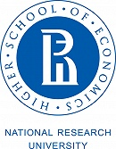
School of Foreign Languages

PROGRAMME

INTERNATIONAL CONFERENCE

Foreign Language Teaching:

Traditions and Innovations

in memory of Dr. Elena Solovova, a renowned scholar in the

field of foreign language teaching methodology

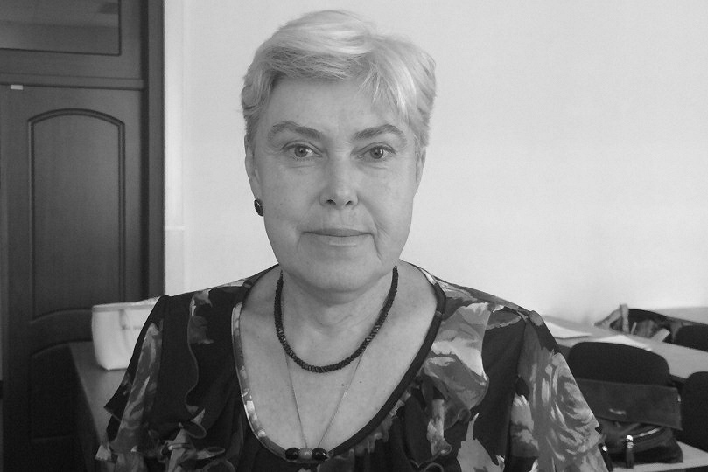
конференция посвящена светлой памяти
известного ученого –
Солововой Елены Николаевны
12–13 December, 2019
Moscow
Timing:
Plenary session talk – 15 min
Session talk – 15 min
Discussion – up to 5 min
CONFERENCE SCHEDULE
December, 12

12.00 – 13.00 Registration of participants (space in front of the Auditorium, 2 floor, Hall Б)
13.00 – 13.20 Opening of the Conference (Auditorium, 2 floor, Hall Б)
13.20 - 15.00 Plenary session (Auditorium, 2 floor, Hall Б)
15.00 - 15.30 Coffee-break (Auditorium, 2 floor, Hall Б)
15.30 - 18.00 Round table talk (Auditorium, 2 floor, Hall Б)

December, 13

9.00 - 10.00 Registration of participants (space in front of the Auditorium, 2 floor, building Б)
10.00 - 10.45 Workshops (rooms in Halls Б and В)
11.00 - 13.30 Sessions (rooms in Halls Б and В)
13.30 - 14.30 Coffee-break (Hall Б, room 210)
14.30 - 17.00 Sessions (rooms in Halls Б and В)
17.00 - 17.30 Final remarks. Closing of the Conference (Auditorium, 2 floor, Hall Б)

Programme

12 December, 2019

Time | Room | Event
12.00 – 13.00 | Space in front of the Auditorium  2 floor,  Hall Б | Registration of participants
13.00 – 13.20 | Auditorium  2 floor,  Hall Б | Opening of the Conference  Welcome addresses  Yaroslav Kuzminov  Candidate of Sciences in Economics, Associate Professor  Rector of HSE University  Mikhail Boytsov  Doctor of Sciences in History, Professor  Dean of Faculty of Humanities, HSE University  Ekaterina Kolesnikova  Candidate of Sciences in Education, Associate Professor,  Chair, Department of Foreign Languages, HSE University  Elena Markova  Candidate of Sciences in Education, Associate Professor  Expert, Department of Foreign Languages, HSE University
13.20 – 15.00 | Auditorium  2 floor,  Hall Б | Plenary session  Svetlana Ter-Minasova  Doctor of Philology, Professor, MSU  Elena Solovova. Colleague, Friend, Ally  Mark Blokh,  Doctor of Sciences in Philology, Professor, Moscow Pedagogical State University  Language as a teacher’s tool  Maria Verbitskaya,  Doctor of Sciences in Philology, Professor, FIPI  Elena N. Solovova’s contribution to language assessment in Russia  Larisa Kuzmina,  Doctor of Sciences in Education, Professor, Voronezh State University  Elena Solovova’s methodological heritage  Svetlana Sannikova  Candidate of Sciences in Education,  Associate Professor, South Ural State Humanitarian Pedagogical University  “Uchitel’! Pered imenem tvoim pozvol’ smirenno preklonit’ koleni” (Oh, venerable Teacher, May we kneel, to glorify Your Name and Contributions)  Carolyn Westbrook, Test Development Researcher, SFHEA  Assessment in Teaching English  Elena Markova  Candidate of Sciences in Education, Associate Professor,  Expert, Department of Foreign Languages, HSE University  Elena Solovova as a person and as a professional
15.00 - 15.30 | Auditorium  2 floor,  Hall Б | Coffee-break
15.30 – 18.00 | Auditorium  2 floor,  Hall Б | Round table  Forever in our hearts: school teachers, university faculty members and university representatives sharing their memories about Elena Solovova  Participants:  Valentina Afanasova  Candidate of Sciences in Education, Associate Professor, NVI  Mark Blokh,  Doctor of Sciences in Philology, Professor, MPSU  Galina Goumovskaya  Doctor of Sciences in Philology, Professor, HSE  Sergey Zasorin  Candidate of Sciences in History, Associate Professor, MSPU  Jacob Kolker  Candidate of Sciences in Education, Professor, RSU  Victoria Levchenko  Doctor of Sciences in Education, Professor, Samara University  Elena Marianovskaya  Candidate of Sciences in Education, Professor, RSU  Elena Nikulina  Doctor of Sciences in Philology, Professor, MPSU  Tatyana Samohina  Candidate of Sciences in Philology, Professor, MPSU  Svetlana Sannikova  Candidate of Sciences in Education,  Associate Professor, South Ural State Humanitarian Pedagogical University  Yulia Skugarova  Candidate of Sciences in Education, Associate Professor, MSU  Marina Solnyshkina  Doctor of Sciences in Philology, Professor, KFU  Marina Sternina  Doctor of Sciences in Philology, Professor, VSU  Irina Tverdohlebova  Candidate of Sciences in Education, Associate Professor, MPSU  Svetlana Ter-Minasova  Doctor of Philology, Professor, MSU  Elena Ustinova  Candidate of Sciences in Education, Associate Professor, RSU  Tatiana Fomenko  Candidate of Sciences in Education, Associate Professor, MPSU  Elena Freydina  Doctor of Sciences in Education, Professor, MPSU  Nataliya Yazykova  Doctor of Sciences in Education, Professor, MPSU
13 December, 2019

Time | Room | Event
10.00-  10.45 |  | Workshops
10.00-  10.45 | Б-213 | Workshop 1  Ludmila Gorodetskaya, Doctor of Sciences in Culture Studies, Professor,  Yulia Skuragova, Candidate of Sciences in Philology, Associate Professor, Lomonosov Moscow State University  21st Century Skills in Teaching Students in Schools and Universities
10.00-  10.45 | Б-210 | Workshop 2  Antoine Marcq, Resource Education  Soft Skills and Communication Skills in English Lessons
10.00-  10.45 | Б-305 | Workshop 3  Claire Barnes, Cambridge Assessment English Presenter  Assessing Productive Skills at C1 level
10.00-  10.45 | Б-314 | Workshop 4  Betty Lou Leaver, English Language Specialist  Debates
10.00-  10.45 | Б-302 | Workshop 5  Leticia Medina, English Language Fellow  Teaching World and British Literature
10.00-  10.45 | Б-407 | Workshop 6  Ekaterina V. Rakhilina, Doctor of Sciences in Philology, Professor,  Work with parallel corpora: examples of scientific problems
10.00-  10.45 | Б-605 | Workshop 7  Johanna Campbell, English Language Fellow  Civic Resource Use to Generate Language Production
Sessions
11.00 - 13.30

11.00 - 13.30 | Б-213 | Session 1  Theory and Practice of Teaching Foreign Languages and Cultures: Traditions and Innovations
11.00 - 13.30 | Б-210 | Session 2  Theory and Practice of Teaching Foreign Languages and Cultures: Traditions and Innovations
11.00 - 13.30 | Б-314 | Session 3  Theory and Practice of Teaching Foreign Languages and Cultures: Traditions and Innovations
11.00 - 13.30 | Б-302 | Session 4  Theory and Practice of Teaching Foreign Languages and Cultures: Traditions and Innovations
11.00 - 13.30 | Б-305 | Session 5  Theory and Practice of Teaching Foreign Languages and Cultures: Traditions and Innovations
 | Б-407 | Session 6  Theory and Practice of Teaching Foreign Languages and Cultures: Traditions and Innovations
 | Б-605 | Session 7  Theory and Practice of Teaching Foreign Languages and Cultures: Traditions and Innovations
 | В-301 | Session 8  Language Assessment as Part of Continuing Language Learning and Teaching
 | В-406 | Session 9  Training and Retraining of Foreign Language Teachers
13.30-  14.30 | Б-210 | Coffee-break
Sessions
14.30 - 17.00

14.30 - 17.00 | Б-213 | Session 1  Theory and Practice of Teaching Foreign Languages and Cultures: Traditions and Innovations
14.30 - 17.00 | Б-210 | Session 2  Theory and Practice of Teaching Foreign Languages and Cultures: Traditions and Innovations
14.30 - 17.00 | Б-314 | Session 3  Theory and Practice of Teaching Foreign Languages and Cultures: Traditions and Innovations
14.30 - 17.00 | Б-302 | Session 4  Theory and Practice of Teaching Foreign Languages and Cultures: Traditions and Innovations
14.30 - 17.00 | Б-305 | Session 5  Theory and Practice of Teaching Foreign Languages and Cultures: Traditions and Innovations
14.30 - 17.00 | Б-407 | Session 6  Theory and Practice of Teaching Foreign Languages and Cultures: Traditions and Innovations
14.30 - 17.00 | Б-605 | Session 7  Training and Retraining of Foreign Language Teachers
14.30 - 17.00 | В-301 | Session 8  Training and Retraining of Foreign Language Teachers
17.00-  17.30 | Auditorium  2 floor,  Hall Б | Final remarks  Closing of the Conference

