Instructions for
students - participants of the SoFL Placement Test (English)
for Bachelor and Specialist Educational Programs at HSE September 2020

The following instructions will aid you in taking the SoFL Placement Test.

- The SoFL Placement Test is located online, on the HSE Smart LMS platform. You can access the test through:
- MarketPlace via https://my.hse.ru/
- Smart LMS via https://edu.hse.ru/
The login and password for the test are the same as your corporate email login and password.

1.1 Authorization in MarketPlace
In order to access your personal account open your web browser and go to https://my.hse.ru/

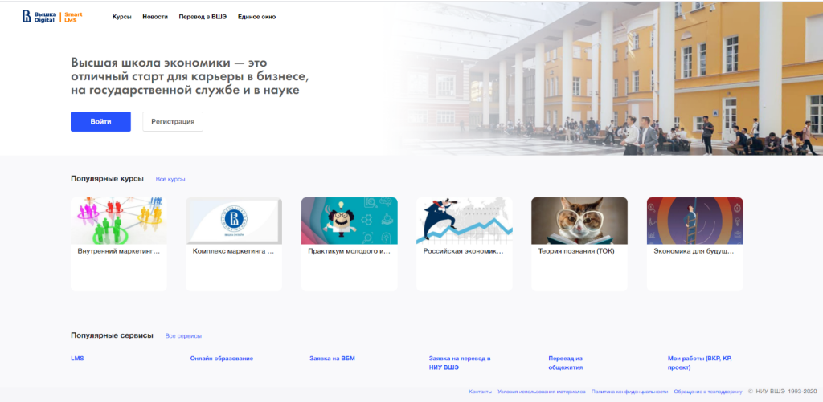

Proceed to enter your login and password in the pop-up window.

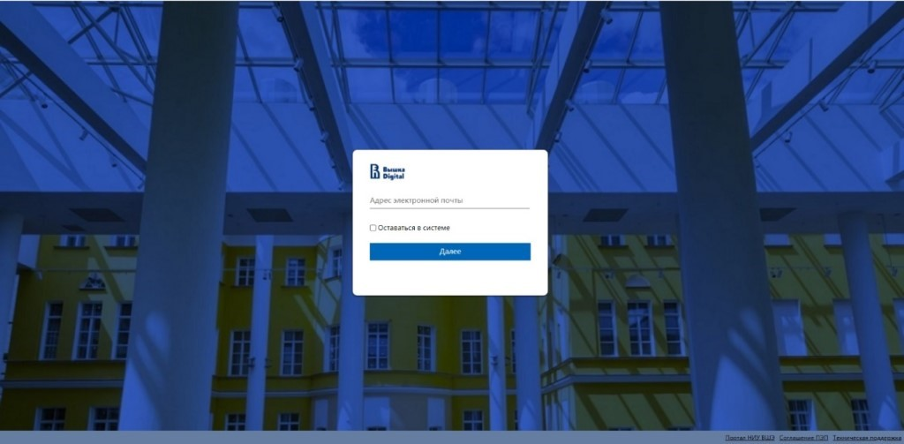
When you login, you will see your personal Student Dashboard.
In order to access the Smart LMS platform select “My courses” in the menu, where all the available courses for the current academic year are displayed.

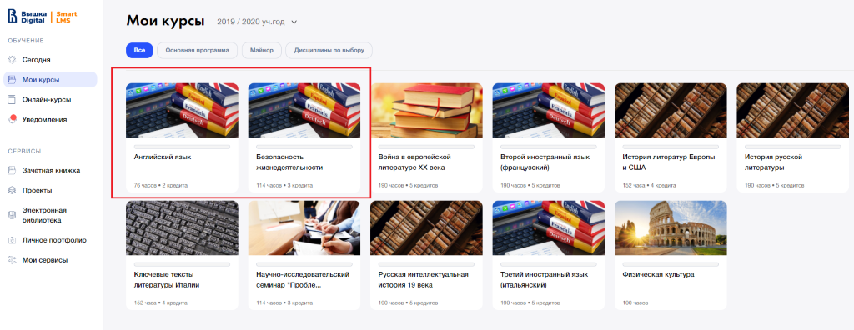Each course contains a brief description and an option to switch to the Smart LMS platform. Once you select this option, the Smart LMS platform will open in a new tab.

1.2 Authorization in Smart LMS
In order to access Smart LMS open your web browser and go to https://edu.hse.ru/
*In order to access data on this site enable cookies on your browser.
Click the login button and enter your corporate login and password.
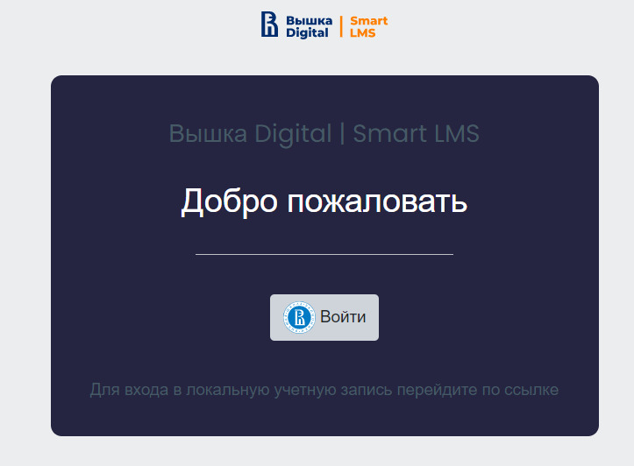
Once you login you will be redirected to your personal student account.
Click the button marked “My courses” in the left-hand side menu and select the “SoFL Placement Test”.
You will be redirected to the SoFL Placement Test main page. To switch to English press the globe sign at the top of the screen.
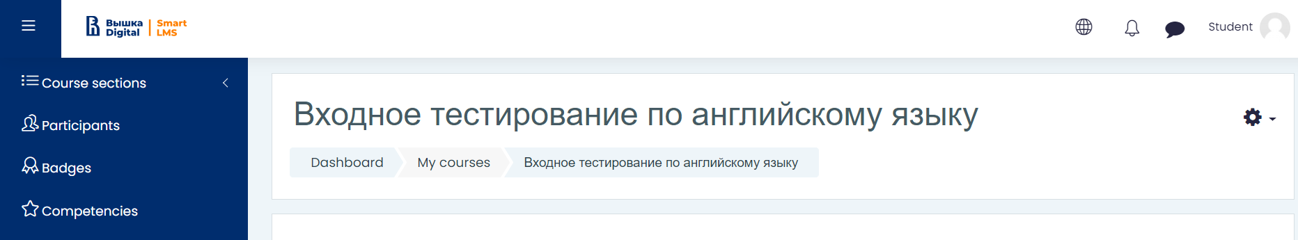
Read through the test instructions carefully. Remember that you only have one chance to take the test, starting with the trial questions. There is a time limit on this test.

- The SoFL Placement Test contains three sections: Reading, Listening and Use of English. You must complete all the tasks in each section.
- The entire test takes 65 minutes to complete. The test is comprised of 80 questions. The maximum amount of points you can gain is 89.
- The language of the test is English.
- We recommend you use your PC or laptop to take this test. You may also use a tablet or a smartphone. Your device must be equipped with speakers, or a headset, or headphones.
- There is a time limit on each section of the test. You must complete the Reading section in no more than 20 minutes, the Listening section in no more than 15 minutes, and the Use of English section in no more than 25 minutes. You will not be able to go back to each section once the time runs out.
- You may only access the sections in order. The Listening section will not be available until you complete the Reading section, and you may only access the Use of English section once you complete all the Listening section tasks. There are no allotted breaks during the Placement Test.
- Before you start working on the main Placement Test questions, you will get a chance to complete three trial questions. Upon answering the questions, you must click the button 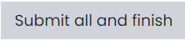 to confirm the completion of this section. After that you may proceed to the Reading section by clicking the button in the bottom right side of the screen. 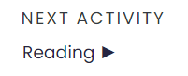
- The Reading section contains 2 texts and 20 questions (10 questions for each text). The questions for the first text are the following: five True/False/Not stated questions and five multiple choice questions. The questions for the second text are the following: five multiple choice questions and five fill in the gaps questions.
You may only use the information from the text to answer the questions. You may go back and change your answers only within the allotted 20 minutes. Once you have completed all the tasks in the Reading section click the button to confirm the completion of this section. You will not be able to go back and change your answers once you click this button. After that you may proceed to the Listening section by clicking the button in the bottom right side of the screen. 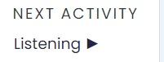
- The Listening section contains 2 audio files and 20 questions (10 questions for each file). The audio player enables you to listen to the files while having all the questions on display in the same tab. Each audio file is split into two fragments: the first fragment of the first audio file corresponds with questions 1-5, the second fragment of the first audio file corresponds with questions 6-10; the first fragment of the second audio file corresponds with questions 11-15, the second fragment of the second audio file corresponds with questions 16-20. You must listen to each fragment in order to complete the tasks. You can only listen to each fragment once. To listen to the audio files press Play on the audio player.
- The questions for the first fragment of the first audio file are True/False/Not stated. The questions for the second fragment of the first audio file are multiple choice. The questions for the first fragment of the second audio file are multiple choice. The questions for the second fragment of the second audio file are fill in the gaps.
- Once you have completed all the tasks in the Listening section click the button to confirm the completion of this section. You will not be able to go back and change your answers once you click this button. After that you may proceed to the Use of English section by clicking the button in the bottom right side of the screen.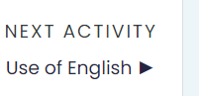
- The Use of English section contains 40 multiple choice questions. You have to choose the correct answer for each question. You may go back and change your answers only within the allotted 25 minutes. Once you have completed all the tasks in the Reading section click the button to confirm the completion of this section. You will not be able to go back and change your answers once you click this button.
- After you complete the entire Placement Test you will be able to view your results in the “Grades” section. In order to view personalized recommendations that will help you choose the most suitable English language course for the first semester of the 2020/2021 academic year you should go back to the SoFL Placement Test main page.
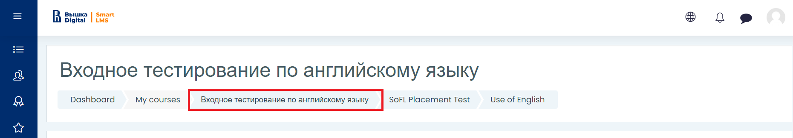
- You will be able to choose your English language course from the selection available at https://courseselect.hse.ru/ . The dates to select your course are 7 September and 8 September or later.
- Here you can find the video instructions:
https://youtu.be/QajJYPWGZRo
- If you have any questions about the SoFL Placement Test, you may direct them to our staff at:
- lms@hse.ru (software, browser, login, and other tech questions)
- dapopova@hse.ru - Diana Popova (test content questions)
- evinogradova@hse.ru - Ekaterina Vinogradova (test content questions)

