Regulations for SoFL Integrative Exam with Asynchronous Proctoring for
Bachelor and Specialist Educational Programmes at HSE (Vnutrenniy ekzamen)
June 4, 21, 22, 23 and June 25 (reserve day) 2021

NB! If something goes wrong during the Exam please do not hesitate to write one e-mail to elearn@hse.ru and one to help@examus.net.
NB! Please indicate any problems encountered with the help of screenshots.

- General Regulations

  - The Regulations define the procedure for SoFL Integrative English Language Exam (the Exam) for Bachelor and Specialist programmes students-participants of HSE in their 1st Year Module 4 2020/2021.
  - The student is obligated to familiarize themself with these Regulations before the start of the Exam and to comply with them until the end of the Exam.
  - The Regulations for SoFL Integrative English Language Exam with Asynchronous Proctoring for Bachelor and Specialist Educational Programmes at HSE (Vnutrenniy ekzamen) June 4, 21, 22, 23, 25 2021 (the Regulations) is designed in accordance with SoFL Integrative Exam Course Description Year 1 Module 4 2020/2021 and does not contradict it.
  - The Exam is conducted in the online format on the HSE Distance Testing Platform remotely with asynchronous proctoring Examus (examinations control).
Asynchronous proctoring means that the identification of the student, as well as the entire exam procedure, are conducted by the programme, the system automatically monitors some of the student’s prohibited actions (a full list of violations is indicated in the Instructions for Using the Examus System).
During the Exam, a video is recorded from the student’s webcam and their computer desktop, which is subsequently checked by an employee of School of Foreign Languages HSE, who either confirms the violation of the Exam procedure or validates the Exam. Please pay attention and follow the Instructions carefully.
  - The date and the time of the Exam:
The Exam is held on the 4th of June (just for the students of Geography of Global Changes and Geoinformation Technology educational programme); June 21, 22, 23 and 25 (reserve day) in groups according to the itinerary.
NB! Students of all educational programs take the Exam strictly on the scheduled day and time of their group according to the Itinerary .
  - Exam format:
The Exam is conducted in written and oral formats, and it consists of four parts: Reading, Listening, Writing, Speaking. The time is divided between the sections of the Exam by the student – participant of the Exam by themself within the total time of the Exam. The recommended time intervals for each part of the Exam are: Reading – up to 25 minutes, Listening – up to 15 minutes, Writing – up to 40 minutes, Speaking – up to 10 minutes. The student-participant can choose the order in which they complete each part of the Exam.
  - The language of the Exam is English.
  - Total time of the Exam is 90 minutes.
  - There is no break in the exam process.
  - The release of the examination papers is carried out remotely in an asynchronous format on June 30, 2021. The results of the Exam (with comments) will be posted in the student’s Personal Account.

- Before the Exam

2.1 The student is obligated to familiarize themself with the Instructions for Using the Examus System .
2.2 The student is obligated to familiarize themself with the User PC Requirements.

To pass the Exam with the Examus proctoring system, you must use:
● Yandex Browser or Google Chrome for OS Windows 7, 8, 8.1, 10.
Install the Examus app for the HSE. Open the link in the Google Chrome browser and download the Examus app for the HSE (only for Windows OS);
● Google Chrome Browser if you are using MacOS version 10.10 or later;
● Yandex Browser if you are using MacOS version 10.12 or later.

NB! The Examus proctoring system is NOT supported by other browsers!

In case of technical issues, you must report them in one email to the HSE Student Support team at the following addresses: elearn@hse.ru and help@examus.net (Examus technical support portal).

2.3 The student is obligated to get authorized:
2.3.1 In the browser settings, the student must enable cookies:

- In Yandex browser, on the browser://settings/content page, scroll down to "Cookies", select "Allowed" and uncheck "Block data and files from third-party sites". Clear Cookies: browser://settings/siteData - "Delete all».

- In Google Chrome browser, on the chrome://settings / page, in the "Privacy and Security" section, select Cookies and other site data – allow and do not block.

    - Open the page https://hse.student.examus.net and click «Сессия НИУ ВШЭ».

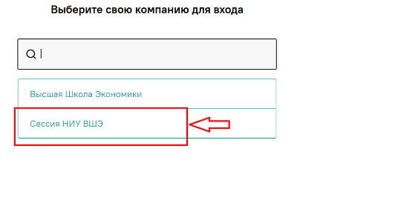

    - In the login page click the blue button «Войти через Единый личный кабинет»

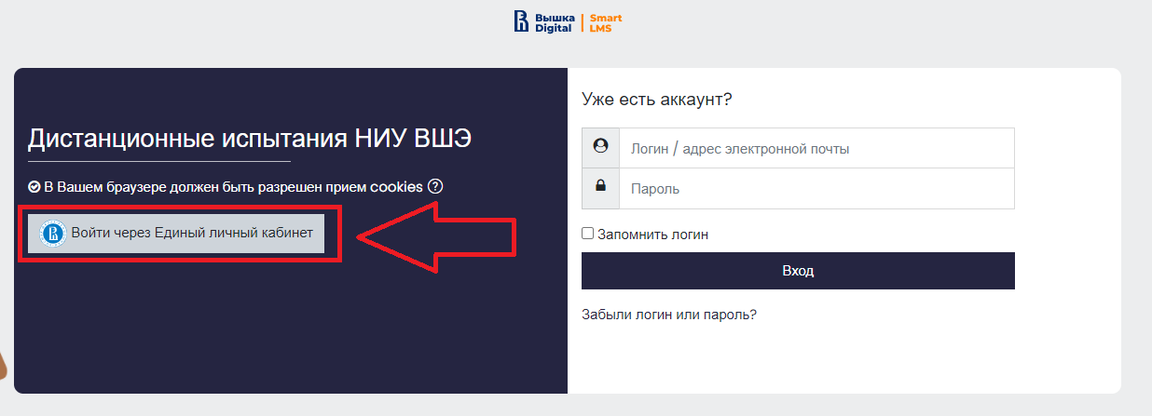

2.3.4 You will go to the HSE Digital authorization page. Enter your corporate account details ***@edu.hse.ru.
    - Logout
If you want to log out, click the «выйти» button:
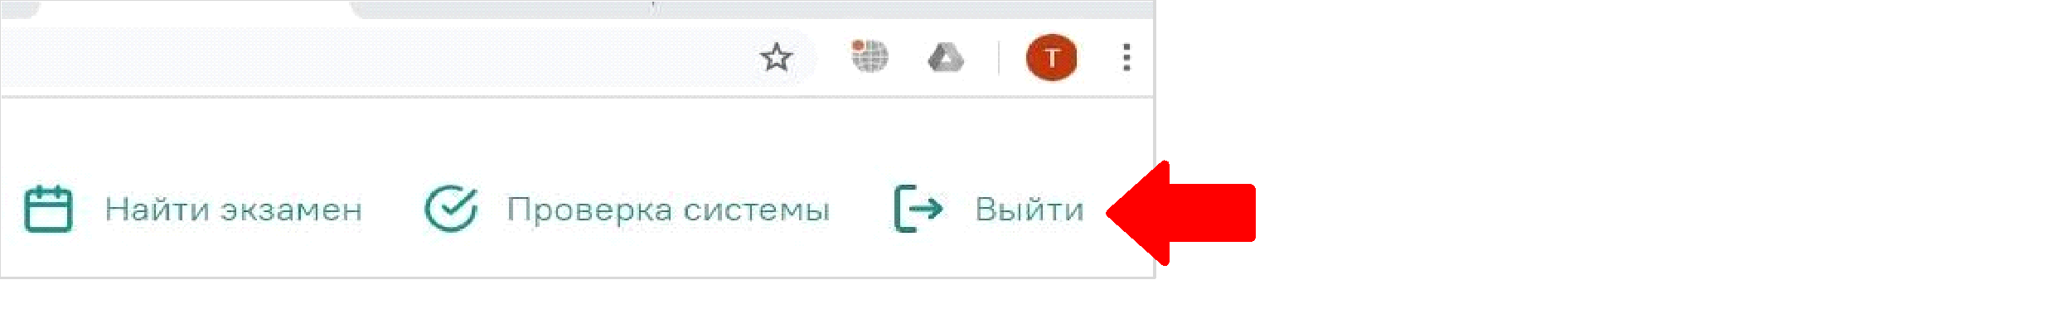

2.4 To participate in the Exam, a student must:
- prepare an identification document (original passport, page with name and photo) for identification before the start of the Exam;
- make sure that the webcam, microphone, headphones or speakers are fully operational, the speed of the Internet is sufficient for the exam requirements (for the best results, it is recommended to connect the computer to the network via a cable);
- prepare the necessary items for the examination tasks (pens, A4 plain sheets to write a draft).
2.5 The student - participant of the Exam conducts a Preliminary Computer Test for the student’s PC no later than 24 hours before the Exam. Please do not hesitate to inform the HSE Student Support Team in case you have any problems (elearn@hse.ru and help@examus.net – Examus Technical Support Portal).

- On the Day of the Exam
3.1 In the Yandex or Google Chrome browser, open the page https://hse.student.examus.net
and log in via the «Сессия НИУ ВШЭ» button. You will see a test available for passing.

3.2. Click «Приступить» to start the exam.
NB! The Exam page will appear in the start window no earlier than 5 minutes before the start of the Exam.
3.3. Read the procedure for taking the Exam, User PC requirements, technical requirements for equipment, confirm you agree with the rules for online testing and click «Продолжить».
3.4 Next you will see the computer settings check window, in which you will be offered the same process as when you click the «Проверка» button from the start window (see paragraph 2.5). After passing the computer check, click the «Продолжить» button, you will be taken to the student’s identity verification window.
3.5 Bring the document up to the camera, click «сфотографировать», and then «отправить»:
NB! If you don't see the camera button and the «отправить» button, use the vertical scrolling of the page.
3.6. After sending a photo of the document, pick up your webcam or laptop, if the camera is built-in, and show your desk, as well as the room around it. For more information about the desktop demonstration, see paragraph 3 of the Instructions for Using the Examus System.
3.7 After sending the document and demonstrating the desktop, you will automatically be transferred to the HSE Distance Testing Platform, where the tasks are placed.
3.8. During the Exam:
● Please be sure to pay attention to the timer that displays the time until the end of the Exam.
● It is not recommended to click between pages in the test tab and use the browser's «Back» button to avoid possible failures. You can use the navigation panel to navigate within the test.
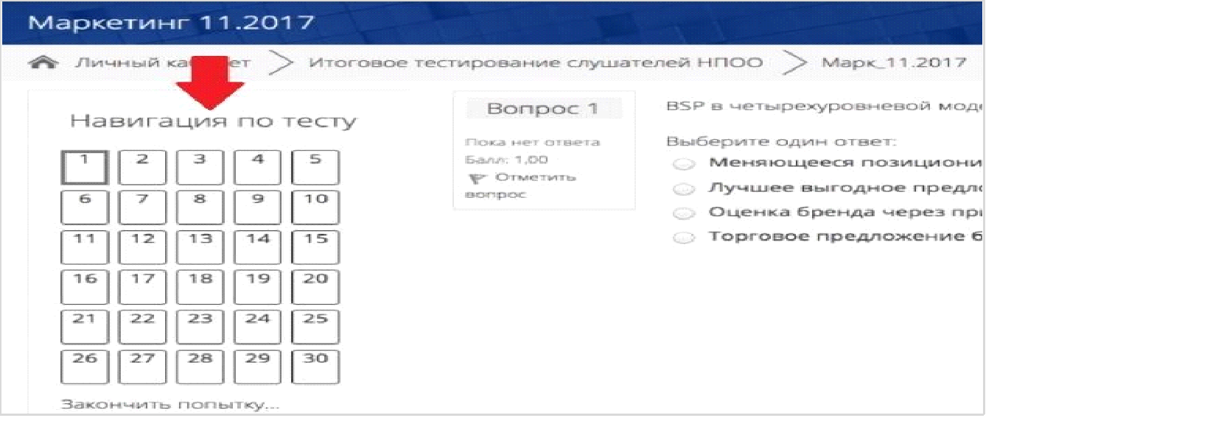
  - During the exam, it is prohibited to:
• turn off the webcam, microphone, reduce its level of sensitivity to sound;
• use auto-corrector apps, notes, textbooks, other educational materials;
• leave the site of the exam (leave the visibility zone of the webcam);
• use headphones, headsets, with the exception of the exam period, when taking the Listening or Speaking (unless your microphone does not work without a headset) sections of the Exam;
• to look away, focusing your eyes for a long time on objects outside the webcam’s visibility range;
• use “smart” gadgets (smartphone, tablet, etc.);
• attract a third party to help with the Exam, talk with a third party during the Exam;
• read tasks out loud;
• stop, rewind and listen to the audio file more than once, except for the case of a short interruption in communication during listening to the audio file for the first time;
- use MS Word or other text editors to carry out the task in the Writing section.

3.10 During the Exam, the student is allowed to:
use blank sheets of paper for drafts, a pen/pencil for taking notes.

  - At the beginning of the Exam, it is recommended that the student - participant of the Exam familiarizes themself with the full version of the assignments according to the Exam Form (see paragraph 1.6).
3.11.1 The tasks in the Reading section are related to reading a text, choosing the correct variant out of the ones given in questions 1-5, and filling in the gaps in sentences 6-10 in accordance with the information from a text.
The student-participant has to enter the requested information in the gaps in the sentences. After completing the assignment, click «Следующая страница» to continue the Exam.
The student-participant has a chance to return to any completed Exam task until the end of the Exam. It is impossible to return to the completed Exam tasks after the Exam is finished.
3.11.2 The tasks in the Listening section are related to listening to the audio file, choosing the correct variant out of the ones given in questions 1-5, filling in the gaps in questions 6-10 in accordance with the information from the audio file. The audio recordings are divided into two parts. Part 1 corresponds to tasks 1-5, part 2 corresponds to tasks 6-10. While listening to an audio file, the tasks are visible onscreen. The tasks are carried out sequentially.
The audio recording can be played only once. It is prohibited for students-participants to stop, rewind and listen to the audio file more than once.
After completing the assignments, click «Следующая страница» to continue the Exam.
The student-participant has a chance to return to any completed Exam task until the end of the Exam. It is impossible to return to the completed Exam tasks after the Exam is finished.
3.11.3 The task in the Writing section is related to writing an essay on one of the six proposed topics.
Before writing an essay a student-participant should choose a topic, click on the chosen topic and start writing an essay.
The student-participant has a chance to change the topic of the essay before the Exam is finished.

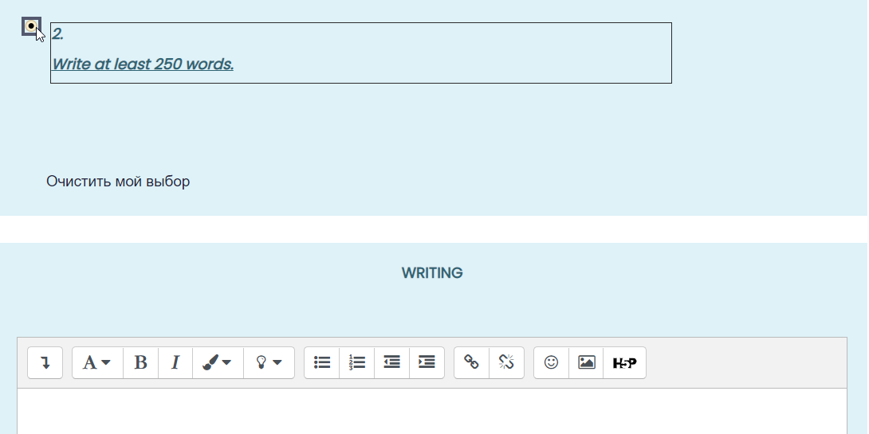
The chosen topic must match the topic of the written essay.

The essay is written on the platform in the field provided for the answer:

It is prohibited to carry out the task in MS Word and other text editors. There is no option to attach a file to the answer. It is allowed to draft the essay while writing. After the Exam is finished, essays will not be accepted.
The student-participant has a chance to return to the Writing section until the end of the Exam. It is impossible to return to the completed Writing tasks after the Exam is finished.
3.11.4 The task in the Speaking section is related to the presentation of a monologue on one of the three proposed topics. The student - participant of the Exam chooses the topic of the monologue themself.
Before completing the assignment, the student-participant must choose a topic out of those available and start recording a monologue. The student-participant has a chance to change the topic of the monologue before the Exam is finished.
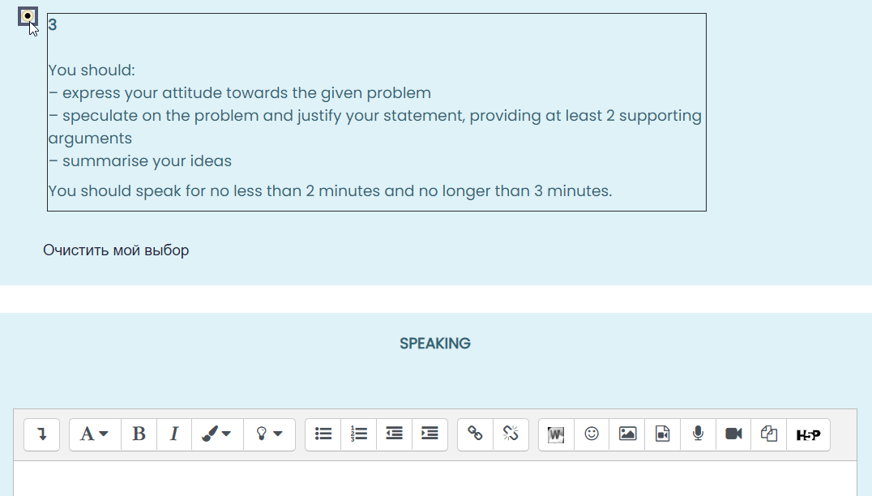
The chosen topic must match the topic of the recorded monologue.
To record the monologue, the student - participant of the Exam must click on the microphone icon in the answer field ().
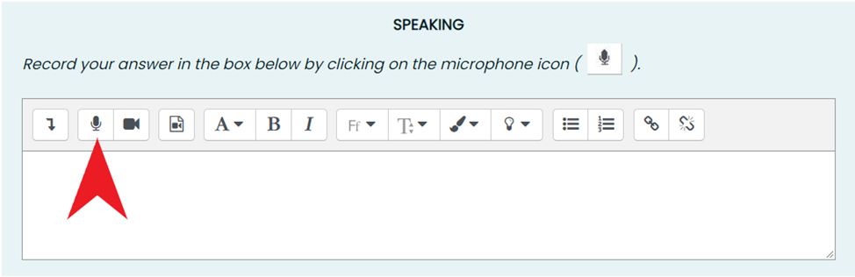
The monologue recording will open in a dialog box.
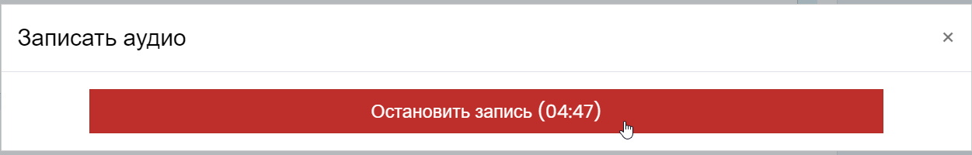

To finish recording, click the «Остановить запись» button.
After that, the student-participant will have the opportunity to check the quality of the recorded monologue.
To submit your monologue, click on the «Прикрепить запись» button. Remember that only in this case the recording will be saved and submitted for verification.
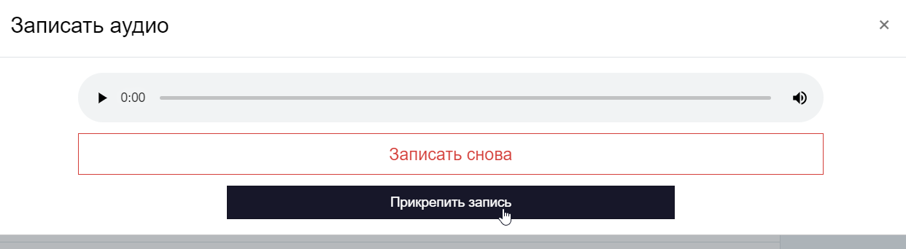
The attached recording of the monologue should look like the following:
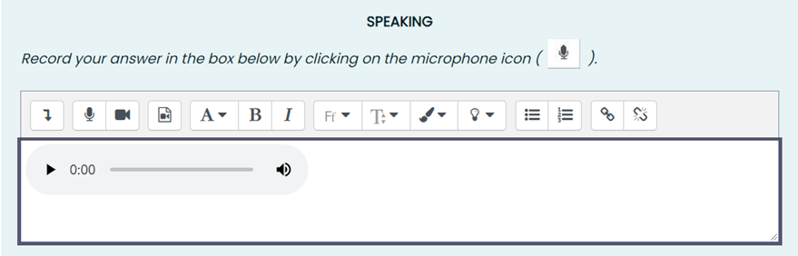
It is impossible to return to the completed Speaking tasks after the Exam is finished.
- Completing the Exam
4.1 The procedure for completing the Exam:
● If you are confident in your answers and are ready to submit them for verification, click «Закончить попытку»;
● After that, you will be taken to the confirmation page, where you will need to click «Отправить все и завершить тест» button;
● When your answers have been submitted, close the Examus tab in the browser (click on the cross in the upper right corner of the screen) or follow the link
5. Communication failure.
Short-term and long-term communication failure during the Exam

5.1 A short-term communication failure during the Exam is considered to be a loss of a student’s network connection with the Exam platform for no more than 5 minutes.

In the event of a short-term communication failure (the page freezes, the Exam session is interrupted, the student does not see the «Начать Экзамен» button), it is recommended to refresh the page (Ctrl + F5), or exit Examus (click on the cross in the upper right corner of the screen) and log in again by following the link to continue the Exam.

5.2 A long-term communication failure during the Exam is the loss of a student’s network connection with the Exam platform for more than 5 minutes. It is not possible to continue taking the Exam in case of a long-term communication failure.

In the event of a long-term communication failure with the platform during the Exam, the student must immediately (on the day of the Exam but not later than 23.59 Moscow time) record the fact of the loss of communication with the platform (take a screenshot or photograph of the entire screen so that the time and the application/website window are visible, get a response from the Internet provider) and report the problem to the Programme Office of their Educational Programme at the corresponding addresses.

The Programme Office studies the student's application. If a technical failure of the equipment or communication with the platform of the Exam during the Exam through no fault of the student is confirmed, the Office allows the student to take the Exam on a reserve day.

5.3. Questions on the content of the Exam can be directed to the speacialists of the Centre of Educational Approaches and Technologies of School of Foreign Languages of the National Research University - Higher School of Economics:

Vinogradova Ekaterina evinogradova@hse.ru
Tsykura Natalya ntsykura@hse.ru

NB! If something goes wrong during the Exam, please do not hesitate to write one email to elearn@hse.ru and one to help@examus.net

NB! Please indicate any problems encountered with the help of screenshots.

