Instructions for
students–participants of the SoFL Placement Test (English)
for Bachelor and Specialist Educational Programmes at HSE 2023, September, 1–13

The following instructions will aid you in taking the SoFL Placement Test.

The SoFL Placement Test is located online, on the HSE Smart LMS platform. You can access the test through Smart LMS via https://edu.hse.ru/course/view.php?id=177237
The login and password for the test are the same as your corporate email login and password.

You will be redirected to the SoFL Placement Test main page. To switch to English press the arrow at the top of the screen next to your initials.
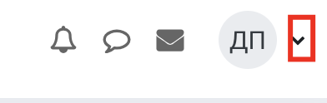
Select “Язык” from the drop-down menu and select English from the following menu.
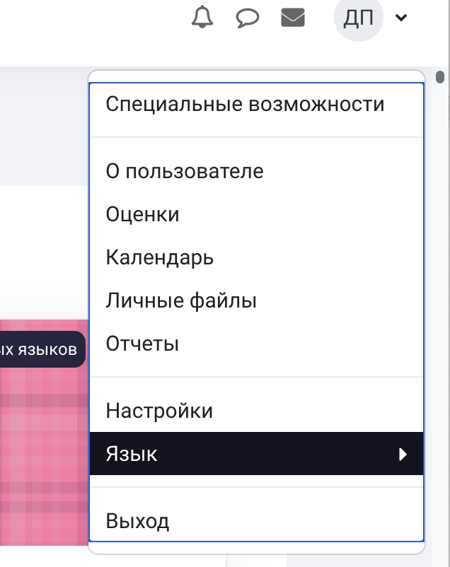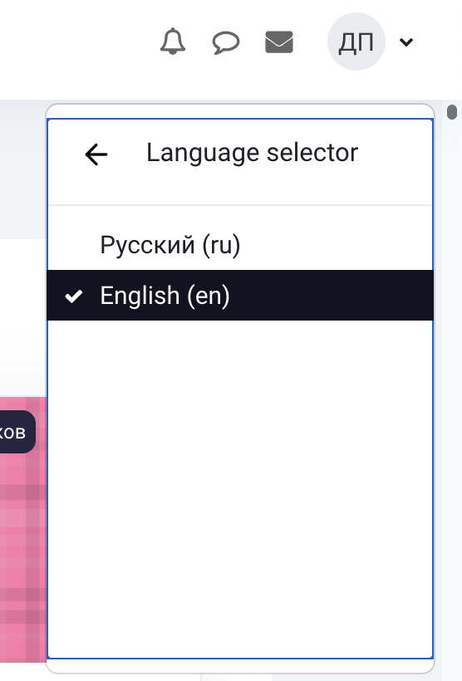
Read through the test instructions carefully. Remember that you only have one chance to take the test, starting with the trial questions. There is a time limit on this test.

- The SoFL Placement Test contains three sections: Reading, Listening and Use of English. You must complete all the tasks in each section.
- The entire test takes 60 minutes to complete. The test is comprised of 89 questions. The maximum amount of points you can gain is 89.
- The language of the test is English.
- We recommend you use your PC or laptop to take this test. You may also use a tablet or a smartphone. Your device must be equipped with speakers, or a headset, or headphones.
- There is a time limit on each section of the test. You must complete the Reading section in no more than 25 minutes, the Listening section in no more than 15 minutes, and the Use of English section in no more than 20 minutes. You will not be able to go back to each section once the time runs out.
- You may only access the sections in order. The Listening section will not be available until you complete the Reading section, and you may only access the Use of English section once you have completed all the Listening section tasks. There are no allotted breaks during the Placement Test.
- The Reading section contains 2 texts and 23 questions. The questions for the first text are the following: five True/False/Not stated questions and five multiple choice questions. The questions for the second text are the following: five multiple-choice questions and five gap-filling questions.
You may only use the information from the text to answer the questions. You will not be able to go back and change your answers. Once you have completed all the tasks in the Reading section click the button to confirm the completion of this section. You will not be able to go back and change your answers once you click this button. After that, you may proceed to the Listening section by clicking the button in the bottom right side of the screen. 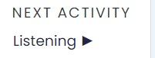
- The Listening section contains 2 audio files and 23 questions. The audio player enables you to listen to the files while having all the questions on display in the same tab. Each audio file is split into two fragments: the first fragment of the first audio file corresponds with Questions 1-5, the second fragment of the first audio file corresponds with Questions 6-10; the first fragment of the second audio file corresponds with Questions 11-15, the second fragment of the second audio file corresponds with Questions 16-23. You must listen to each fragment in order to complete the tasks. You can only listen to each fragment once. To listen to the audio files press Play on the audio player.
- The questions for the first fragment of the first audio file are True/False/Not stated. The questions for the second fragment of the first audio file are multiple-choice. The questions for the first fragment of the second audio file are multiple-choice. The questions for the second fragment of the second audio file are gap-filling.

Once you have completed all the tasks in the Listening section click the button to confirm the completion of this section. You will not be able to go back and change your answers once you click this button. After that, you may proceed to the Use of English section by clicking the button in the bottom right side of the screen.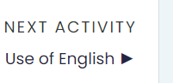
- The Use of English section contains 43 multiple-choice questions. You have to choose the correct answer for each question. You will not be able to go back and change your answers. Once you have completed all the tasks in the Use of English section click the button to confirm the completion of this section.
- After you complete the entire Placement Test, you will be able to view your results in the Grades section. In order to view personalised recommendations that will help you choose the most suitable English language course for the first semester of the 2022/2023 academic year you should go back to the SoFL Placement Test main page.
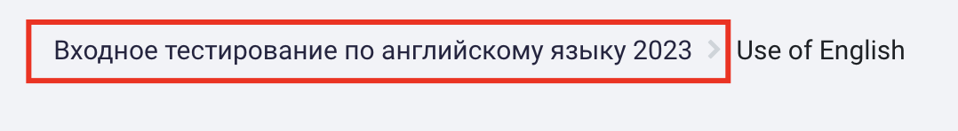
- You will be able to choose your English language course from the selection available at https://courseselect.hse.ru.
- If you have any questions about the SoFL Placement Test, you may direct them to our staff at:
- https://pmo.hse.ru/servicedesk/customer/portal/81/group/294?groupId=294 (software, browser, login, and other tech questions)
- ceat_sofl@hse.ru (test content questions)

